Color Theory & Color Schemes

Definition
# Source: AI Source: Provided by: [Data Path: Persons Table -> ID Column: 1, Name_En Column: Motasem Essam] -> From: [Chatgpt (GPT‑5 Mini)] on [2/12/2026]
Color Theory & Color Schemes is a web design technique that involves choosing and combining colors in a way that creates visually appealing, balanced, and meaningful designs.

Simple Definition
# Source: AI Source: Provided by: [Data Path: Persons Table -> ID Column: 1, Name_En Column: Motasem Essam] -> From: [Chatgpt (GPT‑5 Mini)] on [2/12/2026]
Color Theory & Color Schemes = using colors in a smart way to make a website look good and communicate the right message.

What Color Theory Includes
# Source: AI Source: Provided by: [Data Path: Persons Table -> ID Column: 1, Name_En Column: Motasem Essam] -> From: [Chatgpt (GPT‑5 Mini)] on [2/12/2026]
• Understanding how colors work together (color relationships)
• Primary, secondary, and tertiary colors
• Warm colors (red, orange, yellow) and cool colors (blue, green, purple)
• Color harmony (colors that look good together)

Common Color Schemes
# Source: AI Source: Provided by: [Data Path: Persons Table -> ID Column: 1, Name_En Column: Motasem Essam] -> From: [Chatgpt (GPT‑5 Mini)] on [2/12/2026]
• Monochromatic – different shades of one color
• Analogous – colors next to each other on the color wheel
• Complementary – colors opposite each other (high contrast)
• Triadic – three evenly spaced colors on the color wheel

Purpose of Color Theory & Color Schemes
# Source: AI Source: Provided by: [Data Path: Persons Table -> ID Column: 1, Name_En Column: Motasem Essam] -> From: [Chatgpt (GPT‑5 Mini)] on [2/12/2026]
• Create visual harmony and balance
• Make websites attractive and professional
• Improve readability and contrast
• Help guide user attention
• Communicate brand identity and emotions

Advantages
# Source: AI Source: Provided by: [Data Path: Persons Table -> ID Column: 1, Name_En Column: Motasem Essam] -> From: [Chatgpt (GPT‑5 Mini)] on [2/12/2026]
• Enhances visual appeal
• Improves user experience
• Highlights important elements (buttons, links, CTAs)
• Supports branding and identity
• Makes content easier to read

Disadvantages
# Source: AI Source: Provided by: [Data Path: Persons Table -> ID Column: 1, Name_En Column: Motasem Essam] -> From: [Chatgpt (GPT‑5 Mini)] on [2/12/2026]
• Choosing poor color combinations can make the design look unattractive or unprofessional
• Bad color contrast can reduce readability and user experience
• Overusing too many colors can make the design confusing and messy
• Requires knowledge of color theory to apply effectively
• Some users may have color blindness, affecting accessibility
• Cultural differences may affect how colors are perceived
• Testing is needed to ensure colors look good on different screens and devices

Examples
# Source: AI Source: Provided by: [Data Path: Persons Table -> ID Column: 1, Name_En Column: Motasem Essam] -> From: [Chatgpt (GPT‑5 Mini)] on [2/12/2026]
• Using blue and white for a clean and professional look
• Using contrasting colors for buttons (e.g., red “Buy Now” button)
• Using a soft color palette for a calm website
• Using brand colors consistently across all pages

Difference Between Color Theory & Other Web Design Techniques
# Source: AI Source: Provided by: [Data Path: Persons Table -> ID Column: 1, Name_En Column: Motasem Essam] -> From: [Chatgpt (GPT‑5 Mini)] on [2/12/2026]
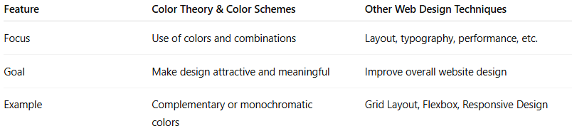
Feature | Color Theory & Color Schemes | Other Web Design Techniques
Focus | Use of colors and combinations | Layout, typography, performance, etc.
Goal | Make design attractive and meaningful | Improve overall website design
Example | Complementary or monochromatic colors | Grid Layout, Flexbox, Responsive Design

